**User Manual of Payment Page**

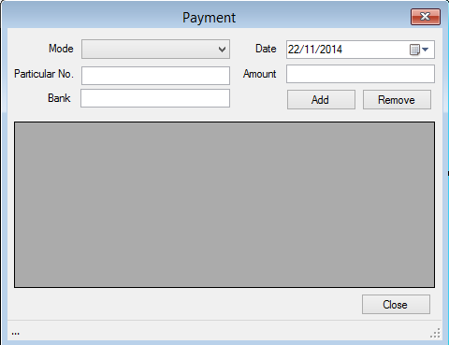

* **This is a payment form where the payment to the advocate by the party, its mode, Date of payment, amount and name of the bank are stored.**